**Create Table query’s:**

CREATE TABLE "REKENINGADMIN"."INVOICE"

( "INVOICEID" NUMBER(10,0) NOT NULL ENABLE,

"INVOICEDATE" TIMESTAMP (6),

"PAYMENTMONTH" NUMBER(10,0),

"PAYMENTSTATUS" VARCHAR2(255 BYTE),

"TOTALAMOUNT" NUMBER(19,4),

"OWNER_SOFINUMMER" VARCHAR2(255 BYTE),

"VEHICLE_CARTRACKERID" VARCHAR2(255 BYTE),

PRIMARY KEY ("INVOICEID")

CONSTRAINT "INVOICE_VEHICLE_CARTRACKERID" FOREIGN KEY ("VEHICLE_CARTRACKERID")

REFERENCES "REKENINGADMIN"."VEHICLE" ("CARTRACKERID") ENABLE,

CONSTRAINT "FK_INVOICE_OWNER_SOFINUMMER" FOREIGN KEY ("OWNER_SOFINUMMER")

REFERENCES "REKENINGADMIN"."OWNER" ("SOFINUMMER") ENABLE

)

CREATE TABLE "REKENINGADMIN"."OWNER"

( "SOFINUMMER" VARCHAR2(255 BYTE) NOT NULL ENABLE,

"ADDRESS" VARCHAR2(255 BYTE),

"CITY" VARCHAR2(255 BYTE),

"NAME" VARCHAR2(255 BYTE),

"POSTALCODE" VARCHAR2(255 BYTE),

"ACCOUNT_ACOUNTID" NUMBER(10,0),

PRIMARY KEY ("SOFINUMMER")

)

CREATE TABLE "REKENINGADMIN"."VEHICLE"

( "CARTRACKERID" VARCHAR2(255 BYTE) NOT NULL ENABLE,

"ACCOUNTDRIVERWEBSITE" NUMBER(1,0) DEFAULT 0,

"ENVIRONMENTCLASS" VARCHAR2(255 BYTE),

"LICENSE" VARCHAR2(255 BYTE) NOT NULL ENABLE,

"OWNER_SOFINUMMER" VARCHAR2(255 BYTE),

"RATECLASS_RATECLASSID" NUMBER(10,0),

PRIMARY KEY ("CARTRACKERID")

CONSTRAINT "FK_VEHICLE_OWNER_SOFINUMMER" FOREIGN KEY ("OWNER_SOFINUMMER")

REFERENCES "REKENINGADMIN"."OWNER" ("SOFINUMMER")

)

**Indexen:**

1. Create bitmap index invoice_bitmap_idx on invoice(paymentstatus);

Resultaten met index:

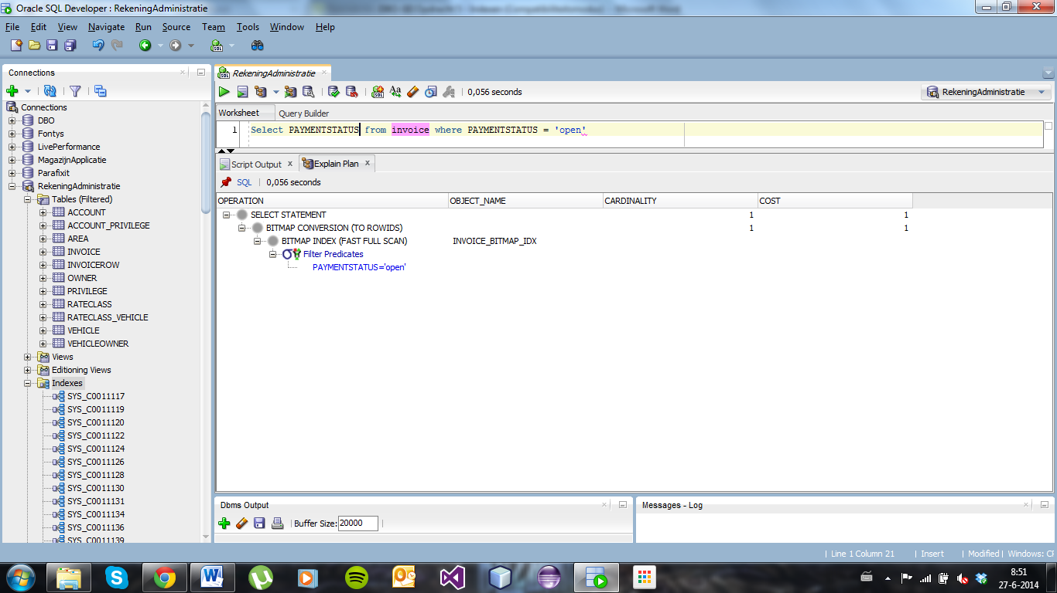

Resultaten zonder index:

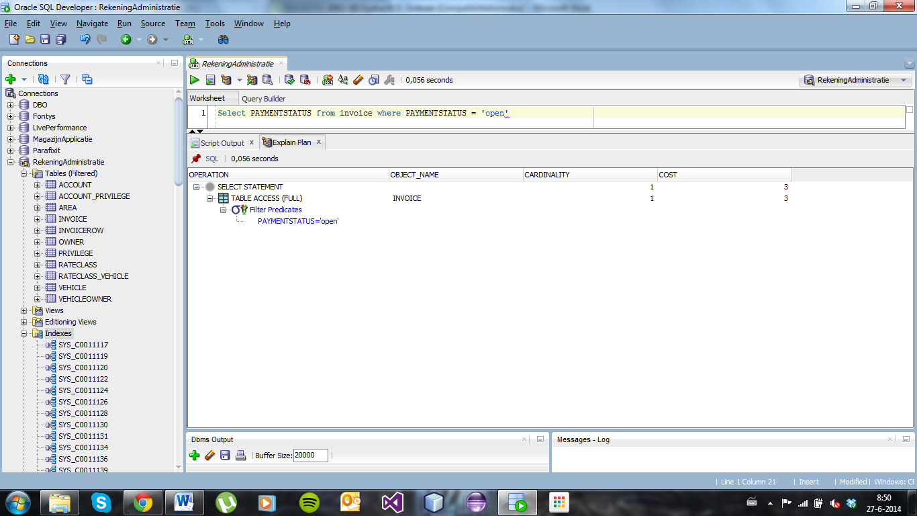

1. Create bitmap index vehicle_bitmap_idx on vehicle(accountdriverwebsite);

Resultaten met index:

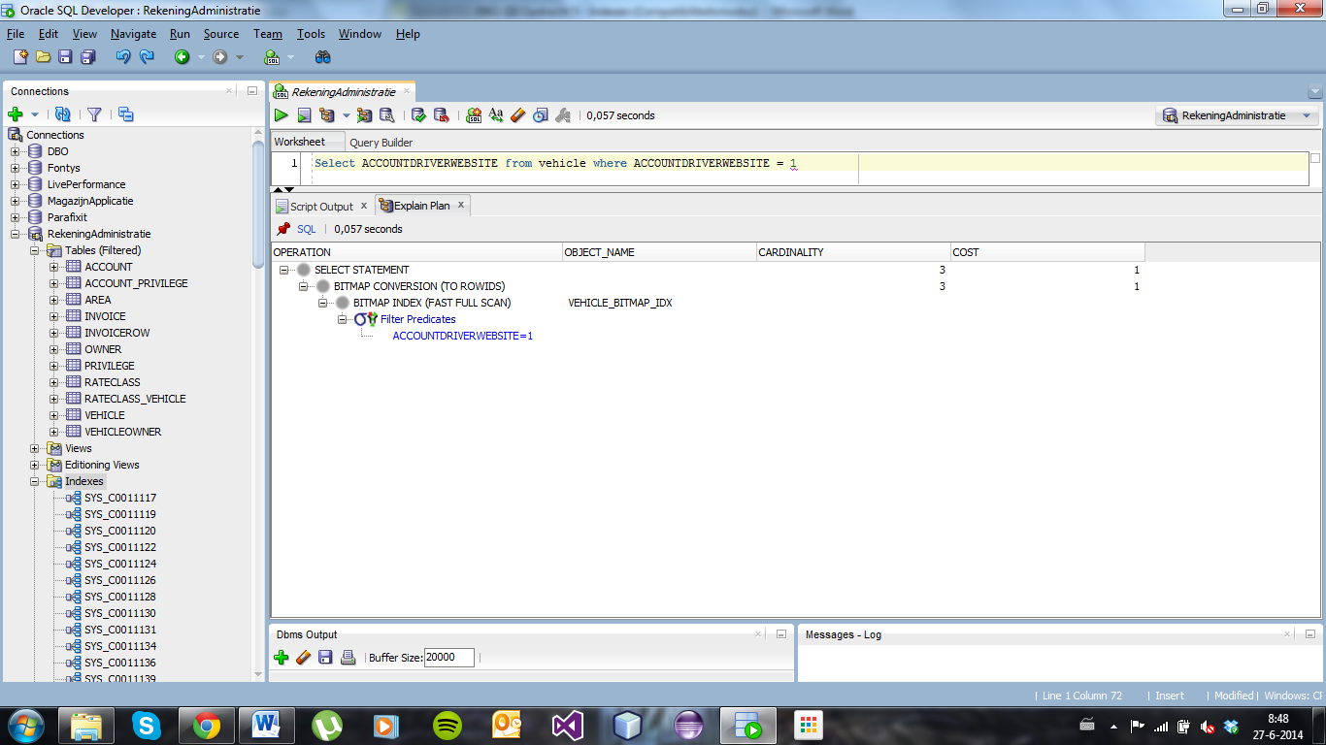

Resultaten zonder index:

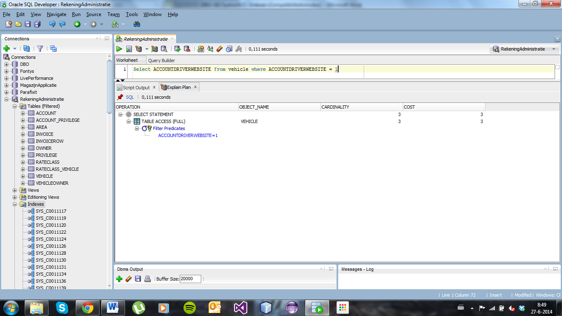

1. create index owner_ind on owner(city)

global partition by range (city)(

partition i_0a values less than ('a%'),

partition i_0b values less than ('b%'),

partition i_0c values less than ('c%'),

partition i_0d values less than ('d%'),

partition i_0e values less than ('e%'),

partition i_0f values less than ('f%'),

partition i_0g values less than ('g%'),

partition i_0h values less than ('h%'),

partition i_0i values less than ('i%'),

partition i_0j values less than ('j%'),

partition i_0k values less than ('k%'),

partition i_0l values less than ('l%'),

partition i_0m values less than ('m%'),

partition i_0n values less than ('n%'),

partition i_0o values less than ('o%'),

partition i_0p values less than ('p%'),

partition i_0q values less than ('q%'),

partition i_0r values less than ('r%'),

partition i_0s values less than ('s%'),

partition i_0t values less than ('t%'),

partition i_0u values less than ('u%'),

partition i_0v values less than ('v%'),

partition i_0w values less than ('w%'),

partition i_0x values less than ('x%'),

partition i_0y values less than ('y%'),

partition i_0z values less than ('z%'),

partition i_max values less than (MAXVALUE)

);

Resultaten met index:

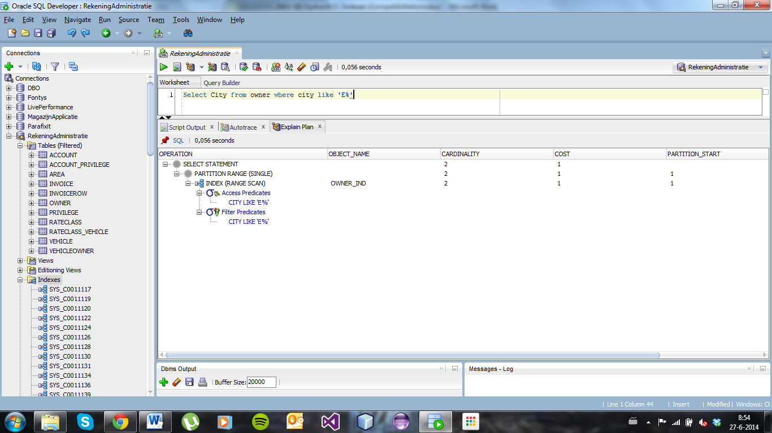

Resultaten zonder index:

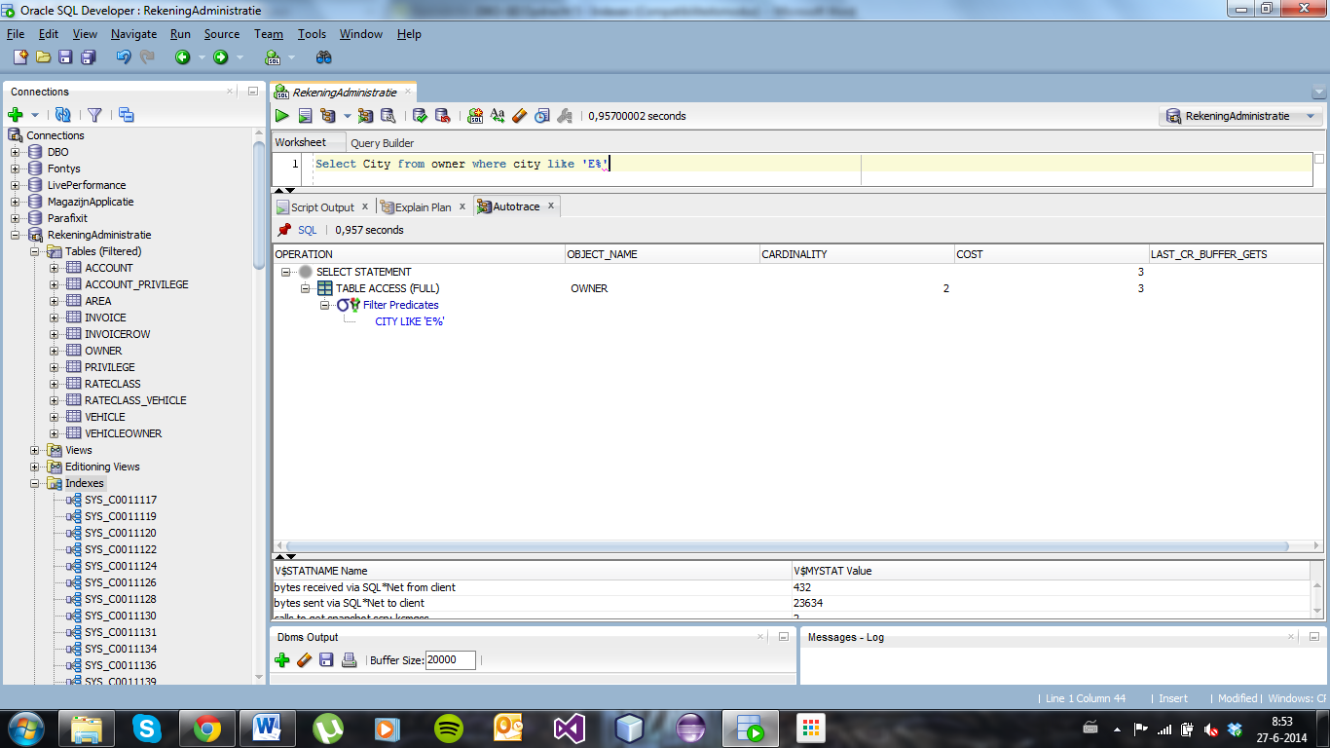

Resultaten met index:

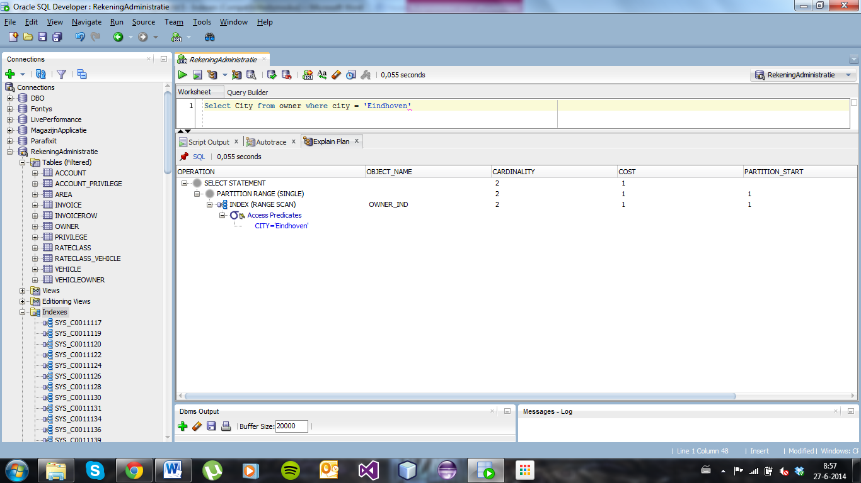

Resultaten zonder index:

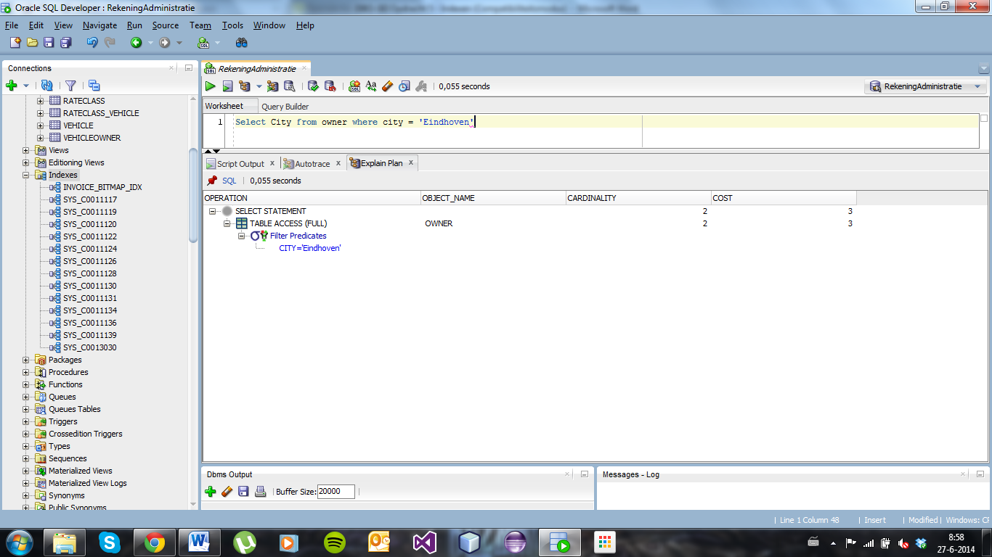

1. create index invoice_ind on invoice(paymentmonth)

global partition by range (paymentmonth)(

partition i_0a values less than (3),

partition i_0b values less than (6),

partition i_0c values less than (9),

partition i_max values less than (MAXVALUE)

);

Resultaten met index:

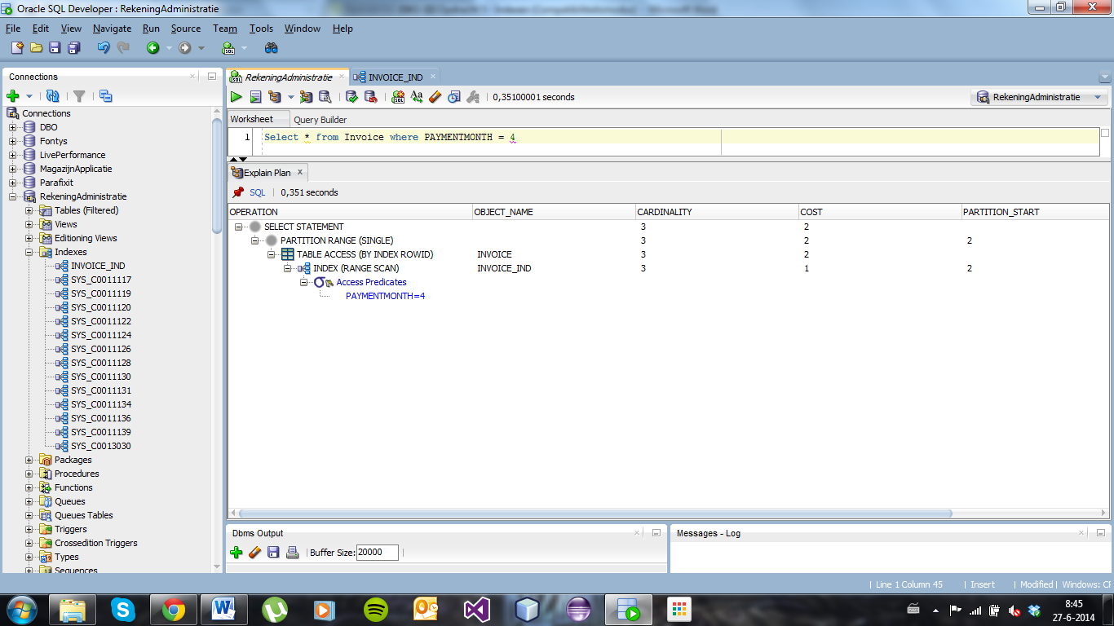

Resultaten zonder index:

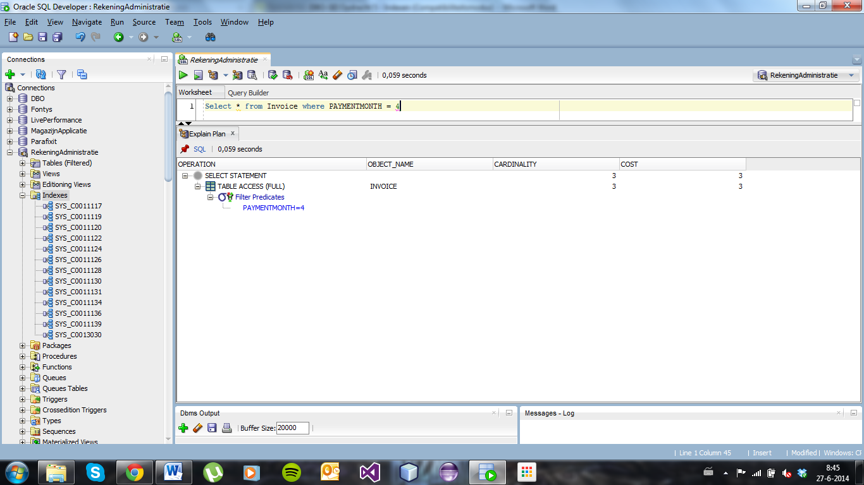

**EXTRA**

Select i.PAYMENTMONTH, i.PAYMENTSTATUS, v.ACCOUNTDRIVERWEBSITE, o.CITY from invoice i,vehicle v,owner o where i.PAYMENTSTATUS = 'open'

and i.PAYMENTMONTH = 4 and v.ACCOUNTDRIVERWEBSITE = 1 and o.CITY like 'E%'

Resultaten met index:

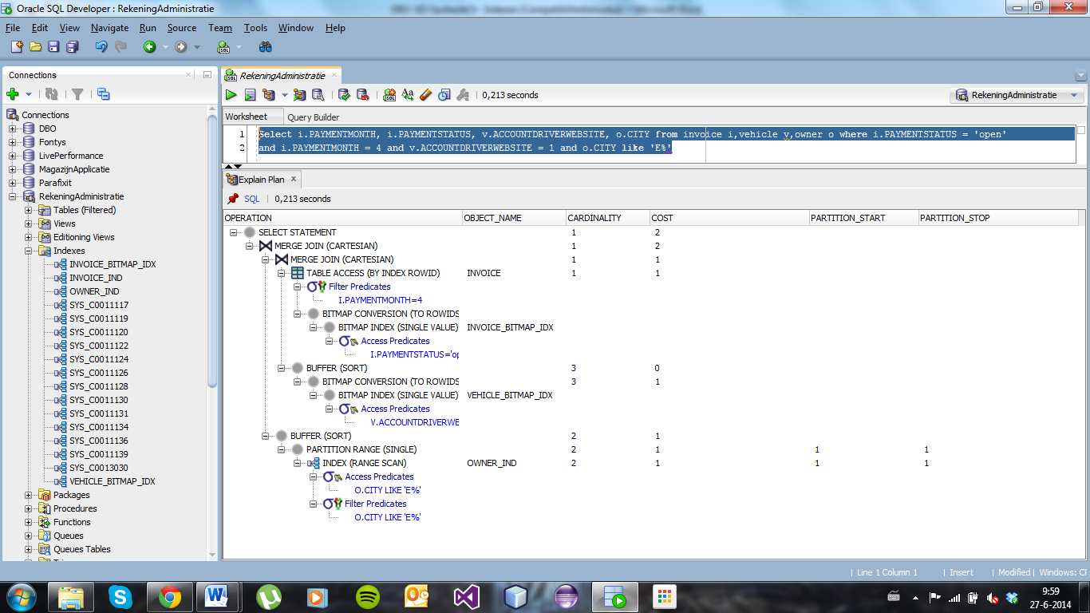

Resultaten zonder index:

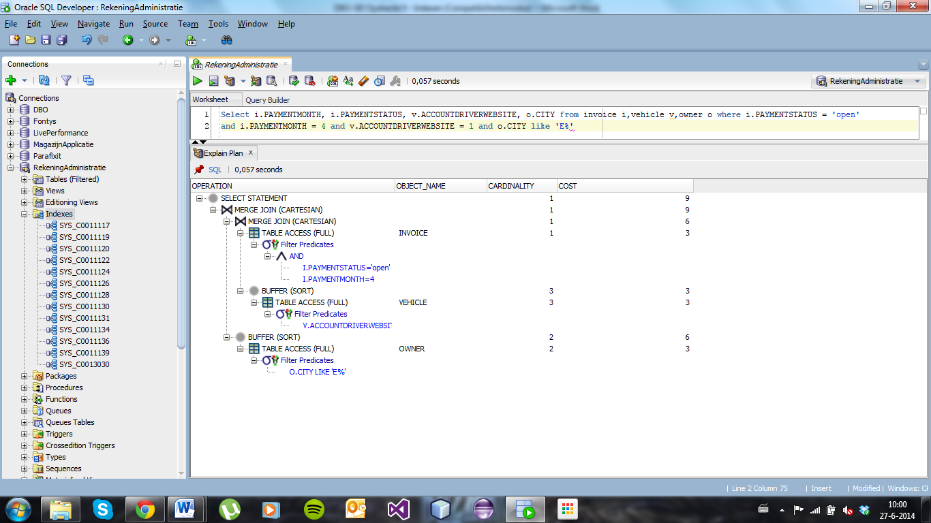

Select * from invoice i,vehicle v,owner o where i.PAYMENTSTATUS = 'open'

and i.PAYMENTMONTH = 4 and v.ACCOUNTDRIVERWEBSITE = 1 and o.CITY like 'E%'

**Conclusie:**

Door het gebruiken van de indexen is de cost van een query een stuk lager. Vooral bij een grote tabel zal dit veel tijd schelen. Hoe complexer de query hoe meer je er op kunt besparen. Wel moet je vaak specifiek aangeven welke kolommen je moet hebben voor de index, wanneer je een SELECT * gebruikt wordt vaak de index niet gebruikt en wanneer je de kolom aangeeft wel.